The Problem Cloud Computing Solves: The "Old Way" vs. The "New Way"

Before the cloud, if a company wanted to launch a website or an application, it had to follow a slow and expensive process:

The "Old Way" (On-Premises): The company had to buy powerful physical servers, storage disks, and networking equipment. This required a huge upfront investment, known as Capital Expenditure (CapEx). They had to guess their peak traffic needs, often buying far more capacity than they used day-to-day, leading to wasted resources. If they needed a new server, the process of ordering, installing, and configuring it could take weeks or even months.

The "New Way" (Cloud Computing): The cloud changes this model entirely. Instead of buying hardware, you rent computing power from a cloud provider (like AWS, Google, or Microsoft). This shifts the cost from a large upfront investment to a manageable monthly bill, known as an Operational Expenditure (OpEx). This model eliminates guesswork, long waiting times, and wasted resources.

What Is Cloud Computing?
Cloud computing is the on-demand availability of computing resources via the internet, typically on a pay-as-you-go basis. Instead of owning and maintaining physical data centers or servers, organizations rent computing power from cloud providers like AWS, Microsoft Azure, or Google Cloud.

Key Characteristics
- On-demand self-service
- Broad network access
- Resource pooling
- Rapid elasticity
- Measured (pay-as-you-go) service
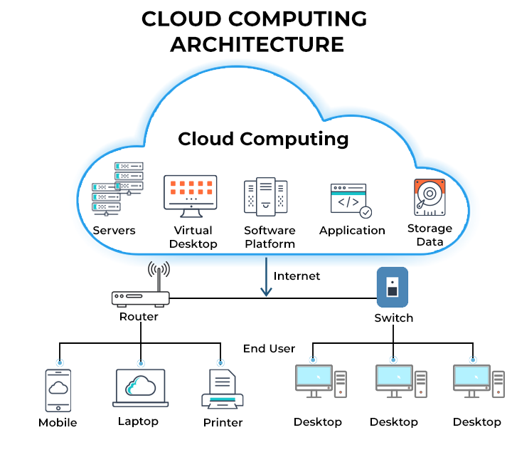

Benefits of Cloud Computing
✅ 1. Cost Efficiency
No need to buy or maintain hardware. Pay only for what you use.
✅ 2. Scalability & Flexibility
Easily scale resources up or down as needed.
✅ 3. High Performance
Cloud providers offer powerful global infrastructure, often outperforming on-premises systems.
✅ 4. Reliability & Availability
Built-in redundancy, multi-zone architectures, and automatic backups.
✅ 5. Security
Cloud platforms offer security controls such as encryption, identity management, threat detection, and compliance certifications.
✅ 6. Faster Deployment
Applications and services can be launched in minutes instead of days or weeks.
✅ 7. Global Reach
Deploy workloads around the world with minimal latency.

Types of Cloud Computing
Cloud computing is organized into service models and deployment models.
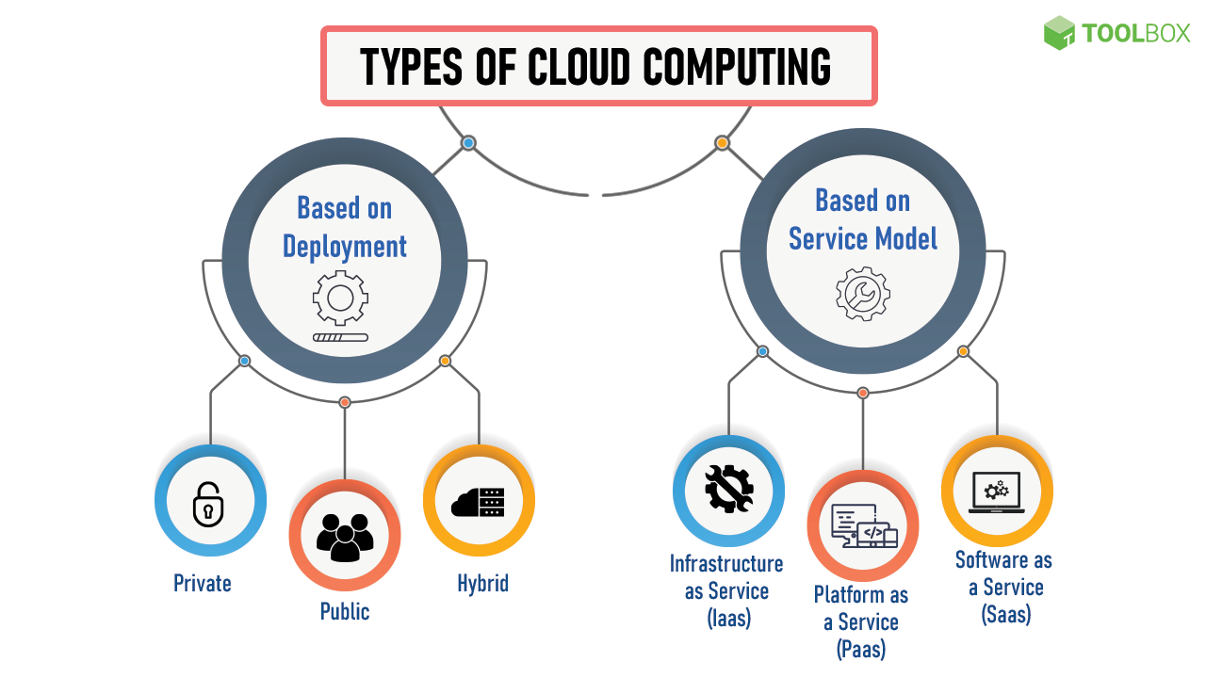
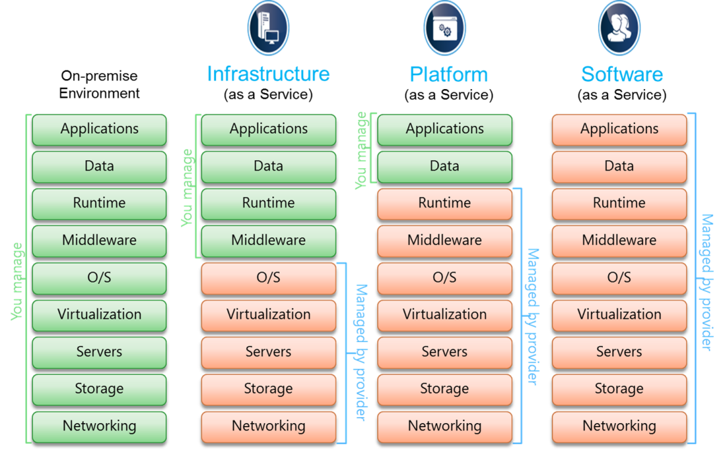

A. Cloud Service Models
1. IaaS (Infrastructure as a Service)
Provides virtualized computing resources over the internet (servers, storage, networks).
Examples: AWS EC2, Google Compute Engine, Azure VMs
Use Case: Hosting websites, running virtual machines, storage solutions.
2. PaaS (Platform as a Service)
Provides a complete environment for developing, running, and managing applications.
Examples: Google App Engine, AWS Elastic Beanstalk, Azure App Service
Use Case: Application development without managing infrastructure.
3. SaaS (Software as a Service)
Delivers software applications over the internet.
Examples: Gmail, Salesforce, Microsoft 365, Slack
Use Case: End-user applications accessible from any device.

B. Cloud Deployment Models
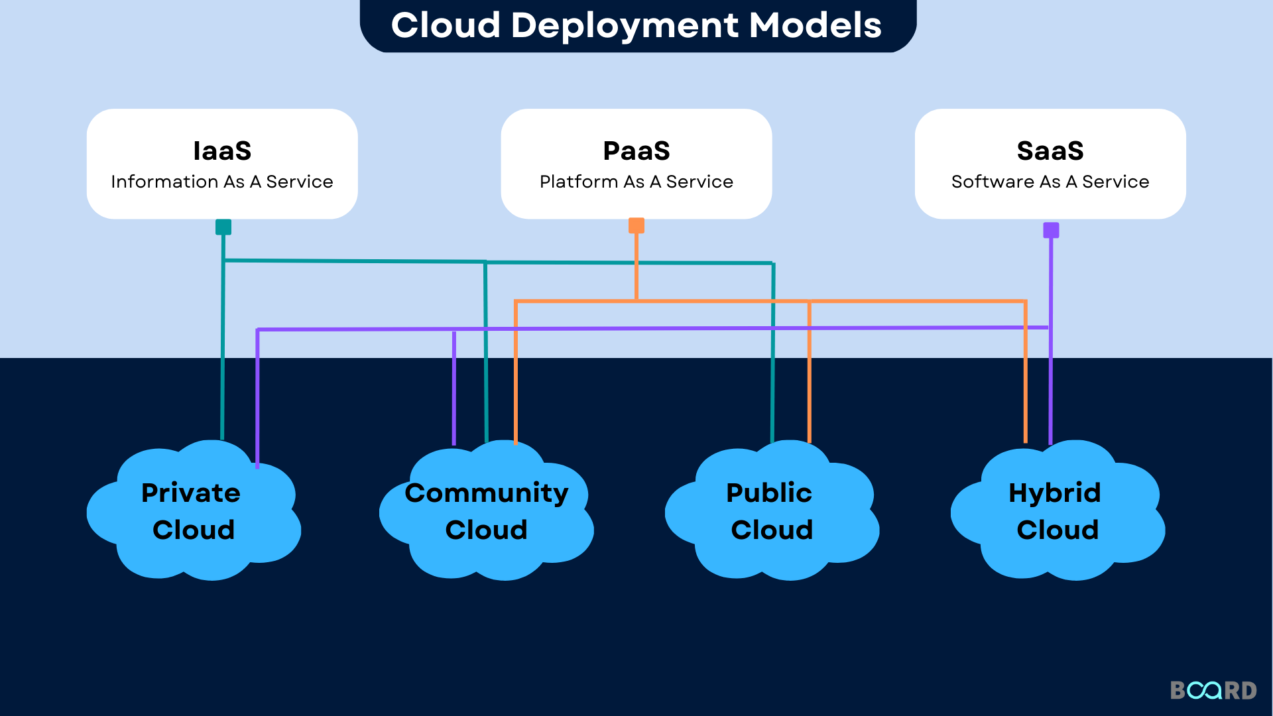
1. Public Cloud
Services offered over the public internet by third-party providers.
Examples: AWS, Azure, Google Cloud
2. Private Cloud
Cloud infrastructure dedicated to a single organization.
Examples: On-prem VMware, OpenStack
3. Hybrid Cloud
Combination of public and private clouds with data and applications shared between them.
Use Case: Enterprises balancing security and scalability.
4. Multi-Cloud
Using multiple cloud providers simultaneously.
Use Case: Avoid vendor lock-in; optimize cost and performance.

===================================================================

Benefits of Cloud Computing
The cloud computing provides several benefits such flexibility and reliability, increased performance and efficiency, and lower IT costs, when compared to on-premises compute resources. In on-premises, the company owns and maintains physical data centers and servers. Lets discuss some benefits as follows −
- Cost Savings − organizations can rent computing resources on-demand instead of buying expensive physical servers. You can choose any cloud service model and you only pay for the resources you actually use.
- Scalability − organizations can quickly scale up and scale down their compute resources to meet the changing demands. The benefits of cloud computing services include the ability to scale elastically.
- Performance − Cloud computing offers greater performance by reducing the network latency for applications.
- Reliability − Cloud computing makes data backup, disaster recovery easier and less expensive.
- Productivity − On-premises datacenters typically require a lot of hardware and software setup, other time-consuming IT management chores. Cloud computing removes the need for many of these tasks, improving the performance of IT teams.
- Security − Cloud computing providers offers security for your data, applications, etc., from potential threats.

Current Trends in Cloud Computing (2024–2025)
🔹 1. AI & Machine Learning Integration
Cloud platforms increasingly host AI workloads, offering tools for training and deploying models (e.g., AWS SageMaker, Google Vertex AI).
🔹 2. Edge Computing
Processing data closer to the source (IoT devices, sensors) to reduce latency.
🔹 3. Serverless Computing
Run code without managing servers. Automatically scales and bills per execution.
Examples: AWS Lambda, Azure Functions.
🔹 4. Kubernetes & Containerization
Kubernetes has become the standard for container orchestration across clouds.
🔹 5. Sustainability and Green Cloud
Providers optimize energy usage and use renewable energy to reduce carbon footprints.
🔹 6. Cloud Security & Zero-Trust Models
Stronger identity-based access and continuous verification across environments.
🔹 7. FinOps & Cloud Cost Optimization
Organizations adopt practices to control and reduce cloud spending.
🔹 8. Industry-Specific Clouds
Healthcare, finance, retail, and telecom clouds tailored for compliance and needs.

Summary
Cloud computing delivers scalable, flexible, and cost-effective computing resources over the internet. Organizations choose service models (IaaS, PaaS, SaaS) and deployment models (public, private, hybrid, multi-cloud) depending on their needs. Current trends emphasize AI integration, serverless solutions, edge computing, sustainability, and stronger cloud security.

Why to Learn Cloud Computing?

Who Should Learn Cloud Computing
Before proceeding with this tutorial, you should have basic knowledge of Computers, Internet, Database and Networking concepts. Such basic knowledge will help you in understanding the Cloud Computing concepts and move fast on the learning track.

https://www.spiceworks.com/tech/cloud/articles/what-is-cloud-computing/

- https://www.tutorialspoint.com/cloud_computing/index.htm
- https://www.w3schools.com/aws/aws_cloudessentials_cloudcomputing.php
- https://www.geeksforgeeks.org/cloud-computing/cloud-computing-tutorial/

FAQs on Cloud Computing

